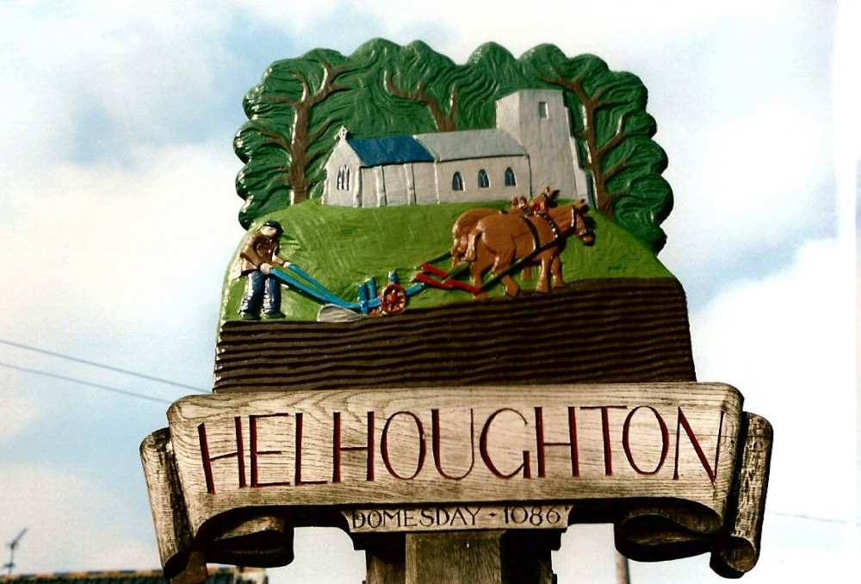

Helhoughton Parish Council

Information Audit

For the purposes of data protection, details are provided below of information held by the Parish Council

|  |  |  |  |  |  |  |  |
| --- | --- | --- | --- | --- | --- | --- | --- |
| **Document** | **Personal details held** | **Purpose** | **How it is held** | **Legal basis** | **Length of time to be held** | **Shared with** | **Purpose of sharing** |
| Personnel - staff | | | | | | | |
| Employment: e.g. contract, pension, CV, appraisal | Contact details, National Insurance number, employment history | For setting up and managing employment of staff | Electronically / hard copy | Legal obligation | Until 6 years after employment has ceased with the Parish Council | Not shared | n/a |
| CVs and applications of job applicants | Contact details and personal details of employment history | Recruitment | Electronically / hard copy | Public task | For 6 months after notifying unsuccessful applicants | Not shared | n/a |
| Councillors | | | | | | | |
| Application for co-option | Contact details and reasons for wanting to become a parish councillor | Reference | Electronically | Public task | For 3 months after councillor vacancy filled | Not shared | n/a |
| Declaration of interest forms | Pecuniary and other interests of parish councillors | Legal requirement | Received by Clerk and then sent to NNDC | Public task | For length of time a councillor is a member of the parish council | On NNDC website with link from the parish council’s website | Public Information |
| Contact list of Councillors details | Contact details | Reference – for the public to contact councillors | Electronically, hard copy, parish council newsletter and notice board (phone numbers only) | Public task | To be updated/amended as change dictates and kept for up to a year after a councillor leaves the council | The public via website. Newsletter and notice board | Public Information |
| Members of the public | | | | | | | |
| Electoral register | Names, addresses | Reference | Electronically / hard copy | Public task | Current year only (until new register is issued by NNDC) | Not shared: the District Council shares this with the parish council | n/a |
| Enquiries from members of the public | Contact details | To request information, pass on information or make a statement | Electronically / hard copy | Public task | For as long as is necessary | Not shared | n/a |
| Contact list of local farmers and landowners | Contact details | In order to contact them regarding a matter relating to their land | Electronically / hard copy | Public task | For as long as farmer/landowner is contact for the land in Sculthorpe | Not shared | n/a |
| List of volunteers | Contact details | Reference – to contact villagers about forthcoming projects | Electronically / hard copy | Public task | To be updated/amended as change dictates | Not shared | n/a |
| List of volunteers for litter pick | Contact details | Reference - to  contact villagers  about forthcoming  litter picks | Electronically / hard copy | Public task | List is normally referred to ahead of the litter pick and revised once a year to ask volunteers if happy to stay on the list | Not shared | n/a |
| List of parishioners | Email address and contact details | For setting up electronic mailing list | Electronically | Public task | To be updated/amended as change dictates | Not shared | n/a |
| Contractors | | | | | | | |
| Contractors providing goods or services to the parish council | Contact details, details of contract between the two parties | Contractual | Electronically / hard copy | Contract | Life of the contract and up to 7 years for auditing purposes | Not shared | n/a |
| Burial Records | | | | | | | |
| Exclusive rights of burial | Contact details of family member/s | Need to keep in contact with family in event of any issues | Electronically / hard copy | Contract | Indefinitely | Not shared | n/a |

Date of adoption: May 2021

Reviewed: May 2023

To be reviewed annually